Global Refund Manager

User Guide

Contents
GLOBAL REFUND MANAGER – GRM 2
GRM installation link 4
Refund of unused ticket, the Fare is nonrefundable, only taxes can be refunded. 5
Refund of unused ticket, cancellation fee applied, all taxes can be refunded, PFC tax breakdown. 8
Refund of partly used ticket, the Fare is nonrefundable after departure, unused taxes can be refunded except of YQ/YR: 10
Refund of partly used ticket issued in Slovakia and paid in EUR, cancellation fee applied: 12
Refund linear 15
Full Refund including all taxes (XF and ZP) without cancel fee 17
Refund of partly used ticket – involuntary refund due to LX1494 cancelled 18
Refund of ticket partly paid by credit card and cash. 21

GLOBAL REFUND MANAGER – GRM
GRM is a new application for ticket refunds that makes them easier and more user friendly but the refund has still to be calculated manually by the agent and the Fare Rule, especially category 16 must be observed carefully. How to calculate the refunded amount – see the examples in next chapter.
Advantages:
- At the beginning of refund process GRM is checking the linkage, if all devices are UP, which is necessary for printing the refund notice. If the itinerary printer is down, GRM can change it to be up again.

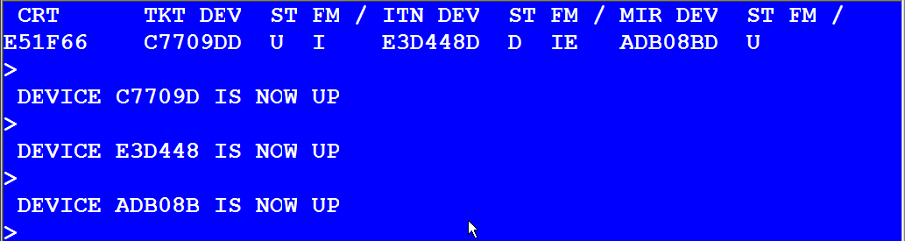

- GRM is also checking the coupon status and continues only when the status is OPEN or ARPT. If the ticket to be refunded has not status OPEN or ARPT, GRM will display following message:

or

- To activate GRM in Smartpoint following entry should be used: >#GRM<.

- If the PNR still exists even if the segments have been already cancelled, GRM is able to take all necessary ticketing data, especially all taxes from Filed Fare History and add them to the refund mask. This is done in case of the second or subsequent exchange or reissue as well. There is no need for PNR to be opened.

Here you can see the difference in paid taxes between GRM and Refund mask from Galileo (TRNE) in case when the second exchange should be refunded.
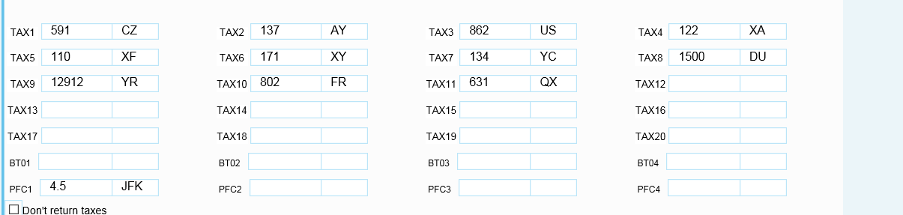

GRM shows all paid taxes from both (all) tickets, it means the originally paid taxes plus the difference additionally collected, for example US tax: original amount collected on the first ticket is CZK 764US and ADC collected on the second ticket CZK 98US = CZK 862
On the contrary the taxes shown in the Refund mask from Galileo (TRNE) are copied only the new (last) ticket and PFC tax breakdown (4.5JFK) must be added by the agent as well.

>*TRNTAX
1: ·8.......·CZ 2: ·14......·AY 3: ·98......·US 4: ·13......·XA
5: ·11......·XF 6: ·18......·XY 7: ·14......·YC 8: ·1500....·DU
9: ·........·.. 10:·........·.. 11:·........·.. 12:·........·..
13:·........·.. 14:·........·.. 15:·........·.. 16:·........·..
17:·........·.. 18:·........·.. 19:·........·.. 20:·........·..
BT01 ·... ·....... BT02 ·... ·....... BT03 ·... ·.......
BT04 ·... ·....... BT05 ·... ·....... BT06 ·... ·.......
BT07 ·... ·....... BT08 ·... ·....... BT09 ·... ·.......
BT10 ·... ·....... BT11 ·... ·....... BT12 ·... ·.......
BT13 ·... ·....... BT14 ·... ·....... BT15 ·... ·.......
BT16 ·... ·....... BT17 ·... ·....... BT18 ·... ·.......
BT19 ·... ·....... BT20 ·... ·.......

The first exchange:
FARE CZK 9675 TAX 583CZ TAX 9257XT TAX 6456YR
TOTAL CZK 6456A

PRG AF X/PAR AF NYC M250.13NLWSRCZ AF X/PAR AF PRG
M229.08NLXSRCZ NUC479.21END ROE20.1889 XT PD802FR P
D631QX PD123AY PD764US PD109XA PD6729XT PD99XF
EXCHANGED FOR: 0579902177241
ORIGINAL ISSUE: 0579902177241PRG25SEP1499999992

The second exchange:
FARE CZK 14550 TAX 16296XT TAX 8CZ TAX 1668XT
TOTAL CZK 6551A

PRG AF NYC 263.32NKXSRCZ AF X/PAR AF PRG M319.40QKX
SRCZ NUC582.72END ROE24.9687 XT CZK14AY CZK98US CZK
13XA CZK18XY CZK14YC CZK1500DU CZK11XF JFK4.5 PD129
12YR PD583CZ PD802FR PD631QX PD123AY PD764US PD382X
T PD99XF
EXCHANGED FOR: 0579902177244
ORIGINAL ISSUE: 0579902177241PRG25SEP1499999992
RLOC 1G 8SVCTU 1A 32YG32
- When the ticket is refunded in different office (PCC) than the ticket has been issued, following warning message is returned by GRM and refund process must be ignored (cancelled).

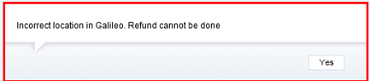

GRM installation link
http://ftp.galileoczsk.cz/download/grm/grm_current.exe
Run the installation file and follow the steps.

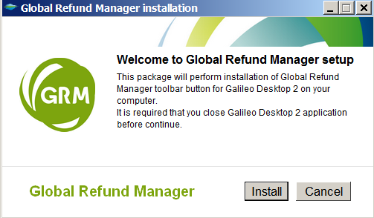
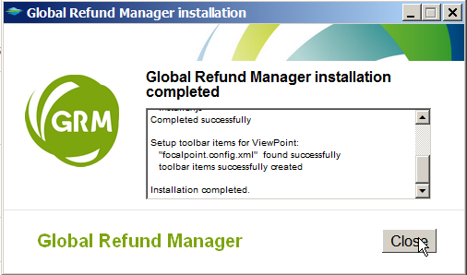

Refund of unused ticket, the Fare is nonrefundable, only taxes can be refunded.

TKT: 114 9902 228061 NAME: VALENTKO/DAVIDMR
ISSUED: 27JAN15 FOP:CASH
PSEUDO: 79YE PLATING CARRIER: LY ISO: CZ IATA: 99999992
USE CR FLT CLS DATE BRDOFF TIME ST F/B FARE CPN
OPEN LY 2524 G 20JUL PRGTLV 2215 OK GHELSHB 1
NVB20JUL NVA20JUL
OPEN LY 2521 N 31JUL TLVPRG 0715 OK NHELSHB 2
NVB31JUL NVA31JUL
FARE CZK 4984 TAX 591CZ TAX 394AP TAX 649IL
TOTAL CZK 6618
FARE RESTRICTIONS APPLY
PRG LY TLV Q32.00 67.41 LY PRG Q32.00 91.22 NUC222.
63END ROE22.3844
RLOC 1G SLBF5Q 1A YP6BZZ

Category 16 of the appropriate Fare rules – Refund conditions:
002 PRGTLV 20JUL15 LY CZK 01509 GHELSHB STAY---/12MBK-G
16. PENALTIES
FROM/TO PRG
CANCELLATIONS
ANY TIME
TICKET IS NON-REFUNDABLE IN CASE OF CANCEL/NO-SHOW.

004 PRGTLV 20JUL15 LY CZK 02461 NHELSHB STAY---/12MBK-H
16. PENALTIES
FROM/TO PRG
CANCELLATIONS
ANY TIME
TICKET IS NON-REFUNDABLE IN CASE OF CANCEL/NO-SHOW.

Step 1: Enter ticket number and press “Continue” button.

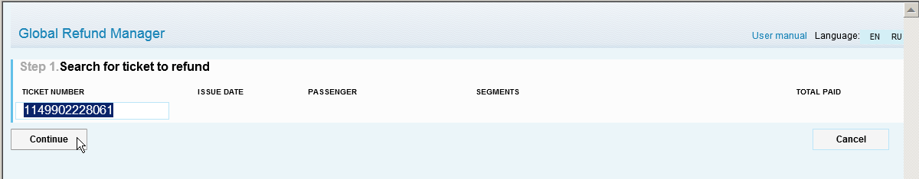

Tick the field below to confirm that Fare Rule – Category 16 has been checked and press “Continue” button.

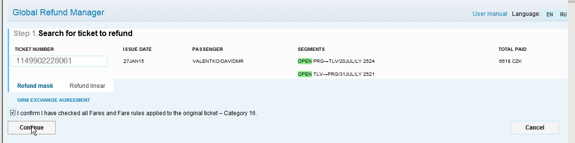

Refund mask is active as a default. The other option is Refund linear which can be used only in case of fully refundable Fare, when all taxes are refunded as well.

Step 2:
The Fare or Equivalent, Total Tax amount, commission and all taxes are automatically added by GRM.
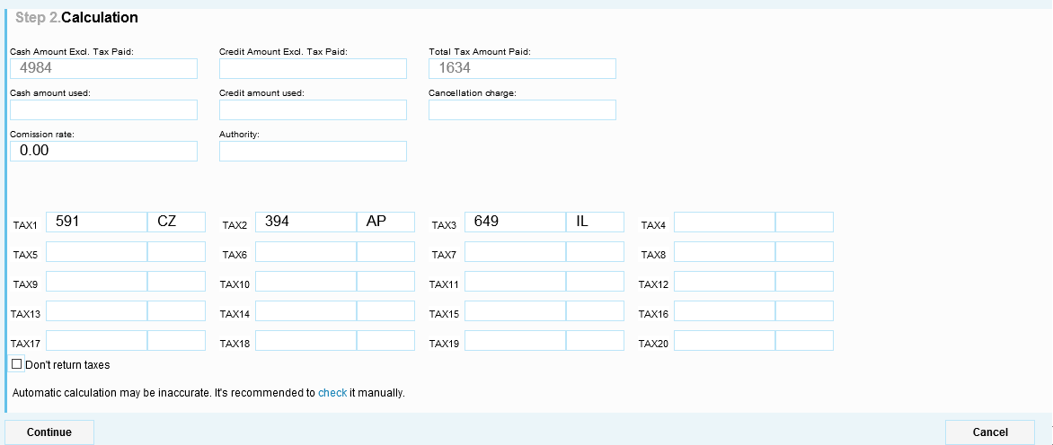

The agent has to add “amount used” (paid cash or by credit card) and cancellation Fee only. In case of nonrefundable Fares the whole Fare amount or Equivalent should be shown as “Cancellation charge”.
When some of the taxes should not be refunded, it is necessary to click on “TAX” field in front of the appropriate tax and it turns gray.

By clicking on check it is possible to display refunded ticket if necessary. Press “Continue” below to move to step 3.

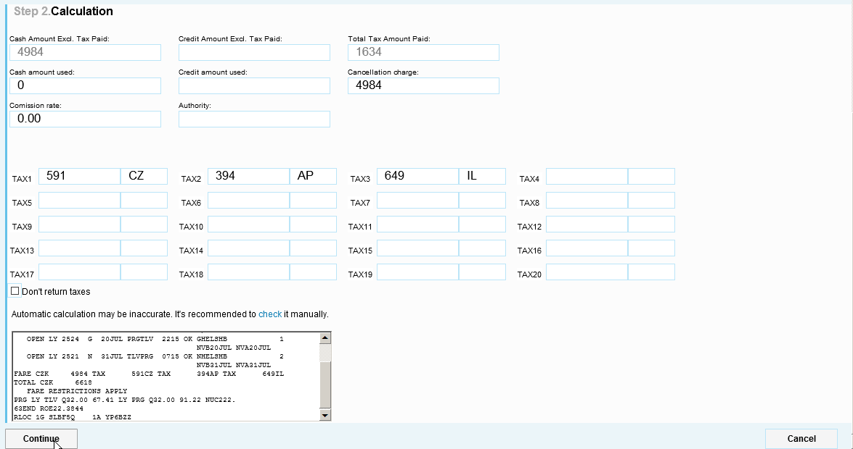

Sometimes “Domestic/International” field is returned. In case that it is not updated automatically by GRM, I for international/ D for domestic type of journey should be entered.
“Authority” field – is used for waver code granted by the carrier in case of involuntary refund.

Step 3:
Check the total amount to be refunded and if it is OK, press “Submit” button below.
The other option is to use “Cancel” button in order to ignore the refund transaction.

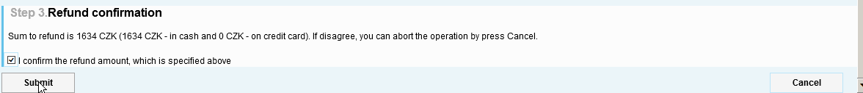

If the refund has been processed successfully, the message in green frame is retuned by GRM.
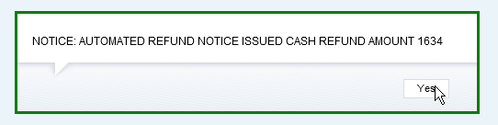

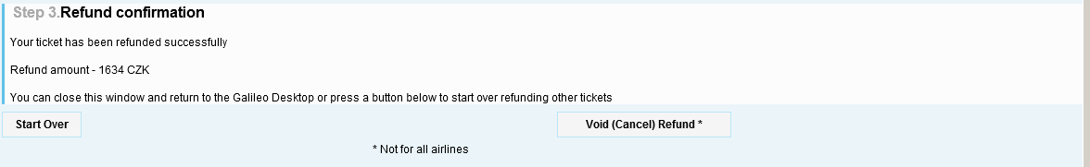

“Start Over” button – will return the refund to the first step and the agent can enter another ticket to be refunded.
“Void (Cancel) Refund” button – this option can be used in case that already processed refund should be cancelled and the coupon status should be changed back to OPEN. This functionality is not supported by all carriers.
When not supported, following message is returned by GRM:

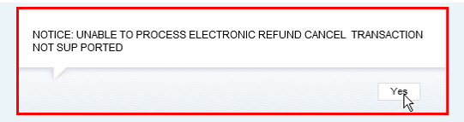

When “Cancel” button is used, following message is returned by GRM:

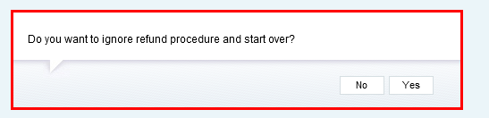

Refund of unused ticket, cancellation fee applied, all taxes can be refunded, PFC tax breakdown.

TKT: 114 9902 228064 NAME: VALENTKO/DAVIDMR
ISSUED: 27JAN15 FOP:CASH
PSEUDO: 79YE PLATING CARRIER: LY ISO: CZ IATA: 99999992
USE CR FLT CLS DATE BRDOFF TIME ST F/B FARE CPN
OPEN LY 7 U 21JUL TLVJFK 1040 OK UIPMSNA 1
NVB21JUL NVA21JUL
OPEN LY 4 U 30JUL JFKTLV 1030 OK UIPMSNA 2
NVB30JUL NVA30JUL
FARE USD 1343.00 TAX 394AP TAX 649IL TAX 1553XT
TOTAL CZK 35618
EQUIV CZK 33022
FARE RESTRICTIONS APPLY
TLV LY NYC Q295.00 376.50 LY TLV Q295.00 376.50 NUC
1343.00END ROE1.0 XT 138AY872US123XA173XY136YC111XF
JFK4.5
RLOC 1G SLBF5Q 1A YP6BZZ

Category 16 of the appropriate Fare rule – Refund conditions:
001 TLVNYC 21JUL15 LY USD 753.00 UIPMSNA STAY-SA/1M BK-U
16. PENALTIES
UNLESS OTHERWISE SPECIFIED
CANCELLATIONS
BEFORE DEPARTURE
CHARGE USD 240.00 FOR CANCEL.
CHARGE USD 240.00 FOR NO-SHOW.
AFTER DEPARTURE
TICKET IS NON-REFUNDABLE IN CASE OF CANCEL/NO-SHOW.

Cancellation fee must be converted to local currency:
>FZSUSD240CZK
RATES LAST UPDATED 05AUG 02:15 AM
EQU CZK5924
BANK SELLING RATE 1USD EQUALS 24.6826 CZK

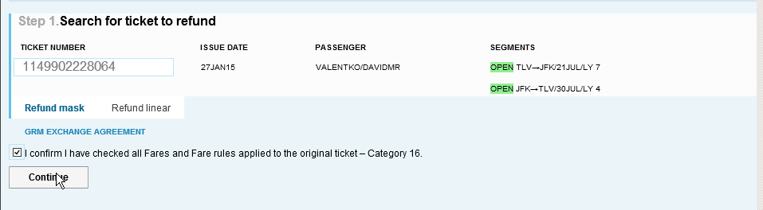

All taxes including PFC tax breakdown are added by GRM automatically.

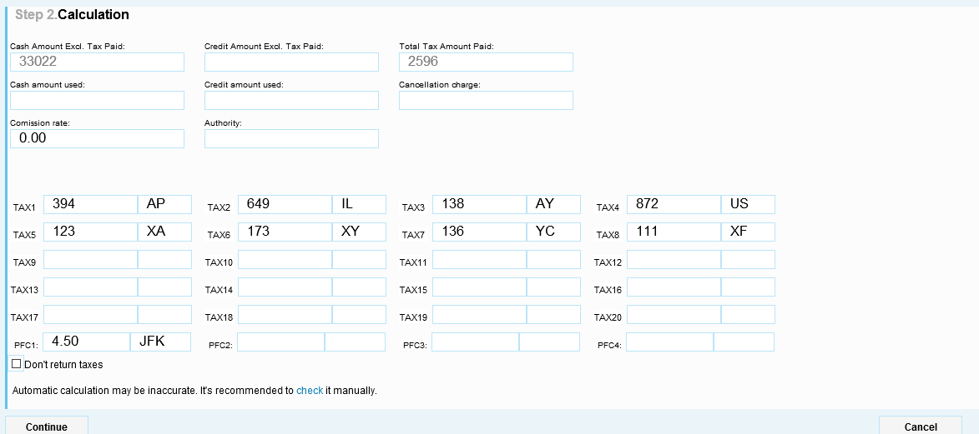

Only the Fare and Cancellation Fee have to be added:

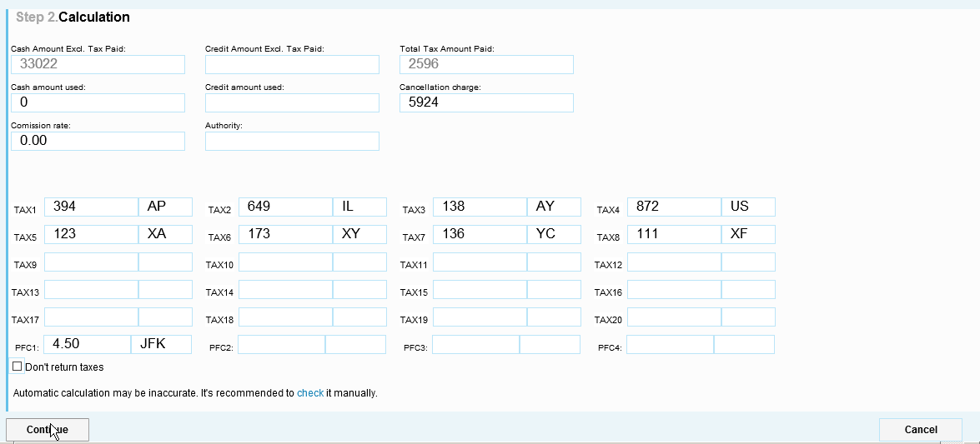

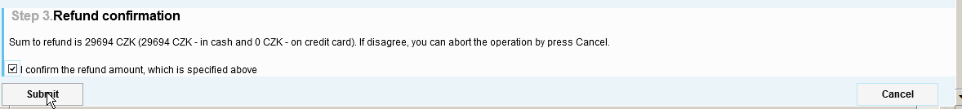

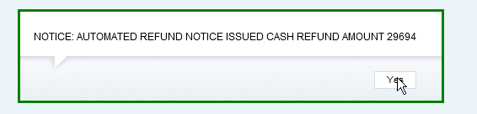

Refund of partly used ticket, the Fare is nonrefundable after departure, unused taxes can be refunded except of YQ/YR:

TKT: 080 8953 303055 NAME: WANG/LELANMRS
PH: 4201 586 564 5579
ISSUED: 29JAN15 FOP:CASH
PSEUDO: 6C9S PLATING CARRIER: LO ISO: CZ IATA: 15210392
USE CR FLT CLS DATE BRDOFF TIME ST F/B FARE CPN
USED LO 92 L 11FEB PEKWAW 0845 OK LPRO3LO 1
NVB11FEB NVA11FEB
USED LO 521 L 11FEB WAWPRG 1430 OK LPRO3LO 2
NVB11FEB NVA11FEB
ARPT LO 528 L 05MAY PRGWAW 1310 OK LPRO3LO 3
NVB05MAY NVA05MAY
ARPT LO 91 L 05MAY WAWPEK 1630 OK LPRO3LO 4
NVB05MAY NVA05MAY
FARE CNY 1850 TAX 591CZ TAX 356CN TAX 8178XT
TOTAL CZK 16433
EQUIV CZK 7308
LO ONLY/NONREF/CHNG RESTR
BJS LO X/WAW LO PRG 149.95 LO X/WAW LO BJS 149.95 N
UC299.90END ROE6.16842 XT 4ND796XW7378YQ
RLOC 1G XFJGZI 1A YRMK89

Category 16 of the appropriate Fare rule – Refund conditions:
001 BJSPRG 11FEB15 LO CNY 01850 LPRO3LO STAYSU+/3M BK-L
16. PENALTIES
FOR LPRO3LO FARES
CANCELLATIONS
AFTER DEPARTURE
TICKET IS NON-REFUNDABLE.
----------------------------------------------
REFUND OF UNUSED TAXES FEES AND CHARGES PAID TO
THIRD PARTIES PERMITTED. FUEL AND INSURANCE
SURCHARGES WILL NOT BE REFUNDED.
-----------------------------------------

Calculation of OW ticket PEK-PRG (used segments 1-2 from PNR) in order to receive already used taxes for segments travelled.
Entry:
>FQS1-2.Y.T29JAN15 and Y = calculation applicable for booking
class Y used for OW fare (Y1RED58).
Entry used to display the Fare calculation:
>F*Q<

FQ-1 M29JAN15 ADT
BJS LO X/WAW LO PRG 2434.98 NUC2434.98END ROE6.16842
FARE CNY 15020 EQU CZK 59329 TAX CN 356 TAX ND 4 TAX XW 398
TAX YQ 3812 TOT CZK 63899

Used taxes: CN 356 / ND 4 / XW 398 / YQ 3812 /

Taxes to be refunded: CZ 591+XW 398 (XW 796 = 398 for outbound + 398 for inbound) = 989

The rest of YQ tax is not refundable according to Category 16 of the appropriate Fare rule.

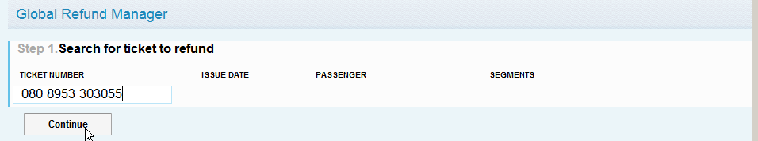

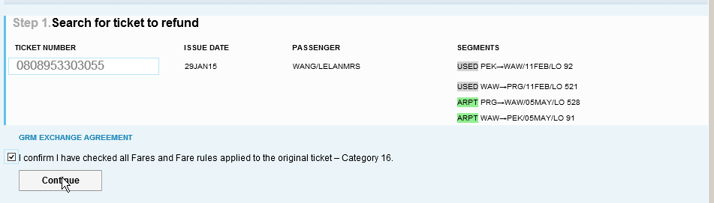

In case of partly used nonrefundable ticket, the whole Fare or Equivalent should be shown in “amount used” field and “Cancellation charge” field is zero (0).
When some of the taxes should not be refunded, it is necessary to click on “TAX” field in front of the appropriate tax and it turns gray. CN, ND and YQ taxes will not be refunded in this example. XW tax – only half of the amount (398) can be refunded and therefore the amount must be changed manually by the agent.

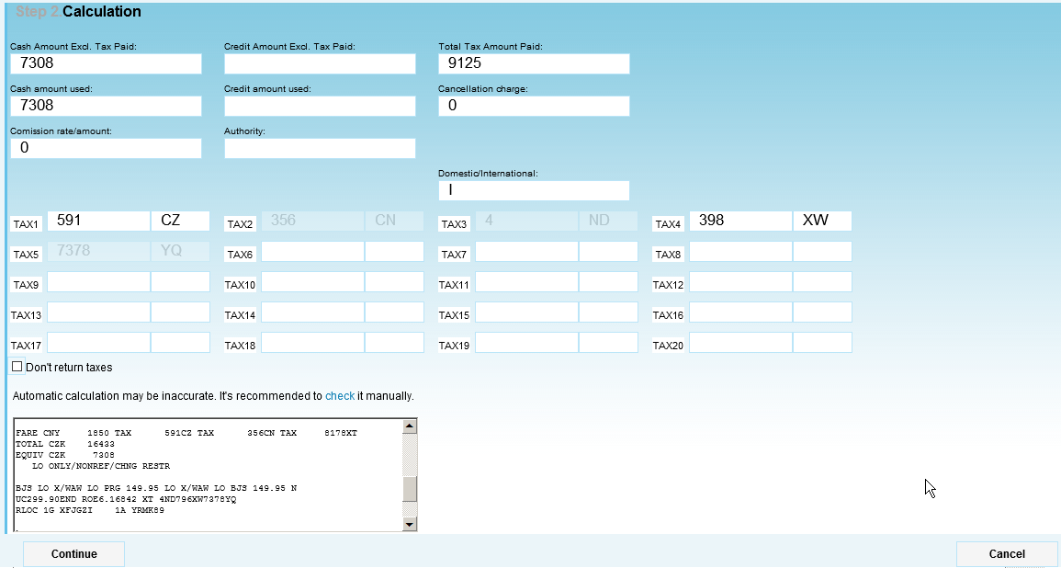

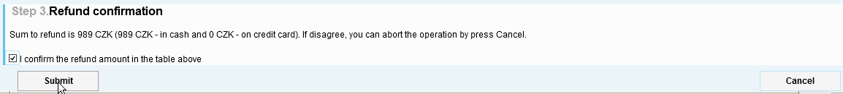

Refund of partly used ticket issued in Slovakia and paid in EUR, cancellation fee applied:

TKT: 180 5299 252798 NAME: KWAH/BUYOUNGMRS
ISSUED: 29SEP14 FOP:CASH
PSEUDO: 7H01 PLATING CARRIER: KE ISO: SK IATA: 78320701
USE CR FLT CLS DATE BRDOFF TIME ST F/B FARE CPN
USED KE 936 M 03NOV PRGICN 1830 OK MLEEKE 1
OPEN KE 935 M 28SEP ICNPRG 1245 OK MLEEKE 2
FARE CZK 33700 TAX 21.19CZ TAX 20.86BP TAX 261.40XT
TOTAL EUR 1528.45
EQUIV EUR 1225.00
NONENDS./RISS CHRG APPLY-CZK1950./RFND PNTY APPLY-CZK2900.
PRG KE SEL 834.61 KE PRG 834.61 NUC1669.22END ROE20
.1889 XT 1.40YQ260.00YR
RLOC 1G ZD945G KE D45UUC 1A 25PUOZ

Calculation of the refund:

1/ calculation of OW (PRGSEL) – segment(s) traveled:

>FDPRGSEL03NOV14.T29SEP14/KE<
MPM 7752 TS
**ADDITIONAL TAXES/FEES MAY APPLY**
PUBLIC FARES HISTORY
CX FARE FARE C AP MIN/ SEASONS...... MR GI DT
CZK BASIS MAX
10 KE 33700R MLEEKE M /12M 11AUG -12DEC R TS Fare used on ticket
18 KE 26286 BOXKE B /12M R TS Fare used for OW
calculation

Category 16 of the appropriate Fare rule – Refund conditions:

>FN*10/16
010 PRGSEL 03NOV14 KE CZK 33700 MLEEKE STAY---/12MBK-M
16. PENALTIES
BETWEEN CZECH REPUBLIC AND KOREA, REPUBLIC OF FOR M-KE TYPE
FARES
ORIGINATING CZECH REPUBLIC -
CANCELLATIONS
ANY TIME
CHARGE CZK 2900 FOR CANCEL/NO-SHOW/REFUND.
CHILD/INFANT DISCOUNTS APPLY.
WAIVED FOR DEATH OF PASSENGER OR FAMILY MEMBER.

The entry used in PNR for calculation of OW for segment (S1) really traveled PRG-SEL: >FQS1.B.T29SEP14<
B = requested calculation in booking class B T29SEP14 = original ticketing date

The entry to display the Fare calculation:
>F*Q<
OW calculation of segment(s) used:
FQ-1 M29SEP14 ADT
PRG KE SEL 1302.00BOXKE NUC1302.00END ROE20.1889
FARE CZK 26286 EQU EUR 956.00 TAX CZ 21.19 TAX YQ 0.70 TAX YR
130.00 TOT EUR 1107.89

Calculation of refund:
Original Fare CZK 33700 Equivalent EUR 1225.00
OW Fare (segment traveled PRGSEL) - CZK 26286 EUR 956.00
CZK 7414 EUR 269.00
Cancellation Fee - CZK 2900 EUR 106.00
The Fare amount to be refunded CZK 4514 EUR 163.00
The Fare amount to be refunded in CZK must be converted to the currency of payment (EUR) using BSR valid on the date of original issue.

Taxes in EUR:
Paid 21.19 CZ – used for OW travel 21.19
Paid 20.86 BP – used for OW travel 0.00 BP 20.86 EUR can be refunded
Paid 1.40 YQ – used for OW travel 0.70 YQ 0.70 EUR can be refunded
Paid 260.00 YR – used for OW travel 130.00 YR 130.00 EUR can be refunded
Taxes to be refunded 151.56 EUR

Total refund: 163 + 151.56 = 314.56 EUR

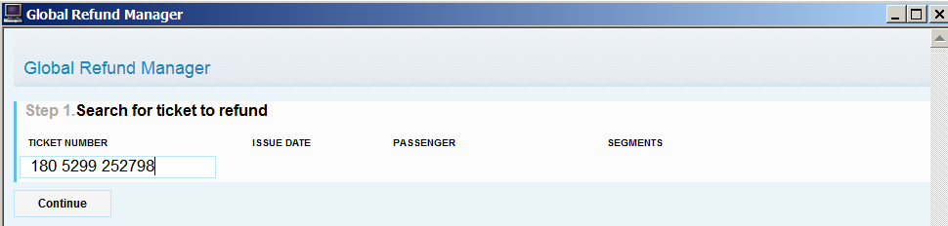

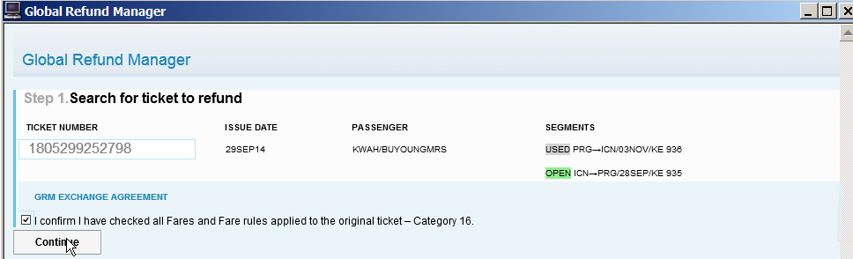

Sometimes the Fare/Equivalent amount is not returned by the system automatically and must be added by the agent manually.

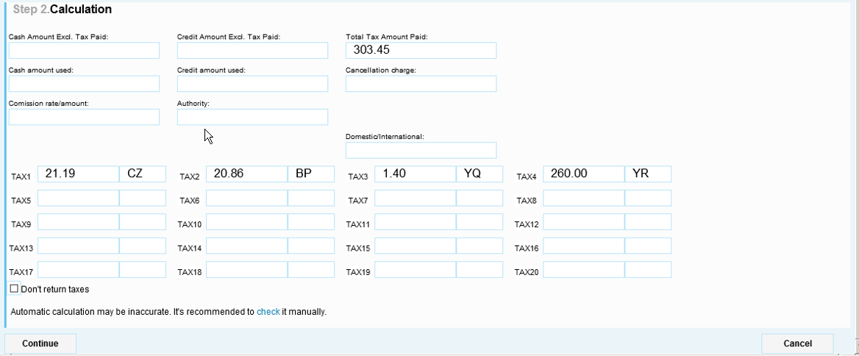
The amount used = EUR 956.00 (Equivalent for OW journey PRG SEL)
Cancellation charge = EUR 106 (CZK 2900 as shown in the appropriate Fare rule converted to the currency of payment - EUR).
Taxes =
CZ tax is not refunded and therefore it is necessary to click on “TAX” field in front of this tax and it turns gray.
YQ and YR taxes must be changed by the agent manually and the amount corresponding to the OW journey should be shown.

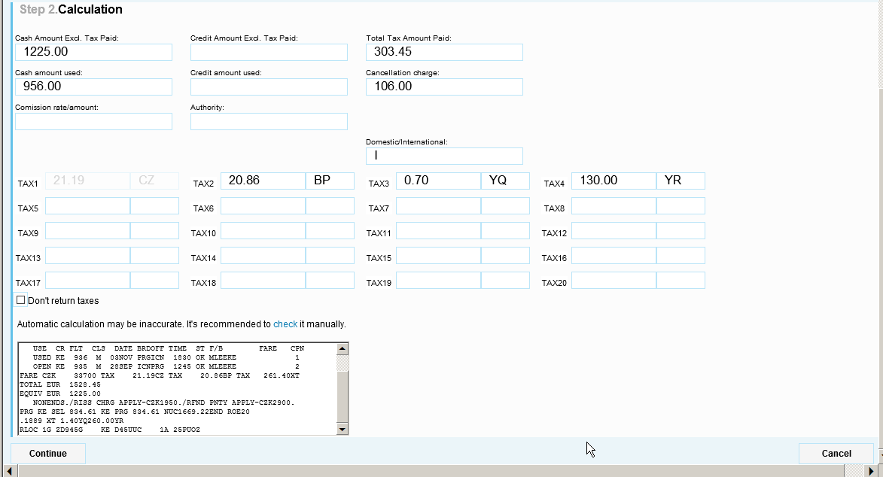

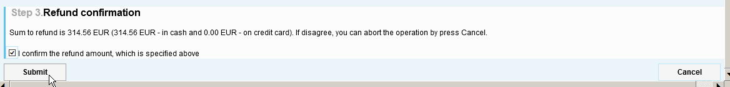

Refund linear

Linear refund is the other option which can be used for refund instead of the “Refund mask”. It can be used only in case of fully refundable Fare, when all taxes are refunded as well.

Example:
Refund of unused ticket, cancelation penalty – EUR 180.00 = CZK 4947, all taxes can be refunded:

TKT: 220 9902 174631 NAME: TRAN/HOANGMR
ISSUED: 24SEP14 FOP:CASH
PSEUDO: 79YE PLATING CARRIER: LH ISO: CZ IATA: 99999992
USE CR FLT CLS DATE BRDOFF TIME ST F/B FARE CPN
OPEN LH 1691 U 03JUN PRGMUC 1315 OK UKRCCZW 1
NVB03JUN NVA03JUN
OPEN LH 6790 U 03JUN MUCYYZ 1530 OK UKRCCZW 2
NVB03JUN NVA03JUN
OPEN LH 6779 U 30JUN YYZFRA 2140 OK UKRCCZW 3
NVB30JUN NVA30JUN
OPEN LH 1396 U 01JUL FRAPRG 1220 OK UKRCCZW 4
NVB01JUL NVA01JUL
FARE CZK 27650 TAX 583CZ TAX 219DE TAX 8934XT
TOTAL CZK 37386
FL/CNX/CHG RESTRICTED
CHECK FARE NOTE
PRG LH X/MUC LH YTO 684.78 LH X/FRA LH PRG 684.78 N
UC1369.56END ROE20.1889 XT 1054RA514CA496SQ65RC6805YQ
RLOC 1G TDJ0TS 1A 3X9PD2

Category 16 of the appropriate Fare rule – Refund conditions:

>FN*20/16
020 PRGYTO 25MAY15 LH CZK 27650 UKRCCZW STAY- V/12MBK-U
16. PENALTIES
UNLESS OTHERWISE SPECIFIED
CANCELLATIONS
ANY TIME
CHARGE EUR 180.00 FOR CANCEL/NO-SHOW/REFUND.
REFUND OF UNUSED FEES AND TAXES PERMITTED.

Cancellation penalty converted to the currency of payment:
>FZSEUR180CZK
RATES LAST UPDATED 12MAY 08:44 AM
EQU CZK4947
BANK SELLING RATE 1EUR EQUALS 27.4808 CZK

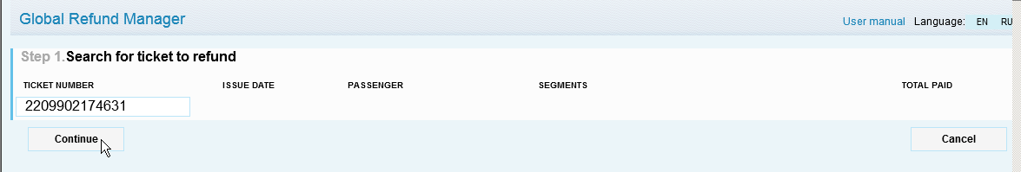

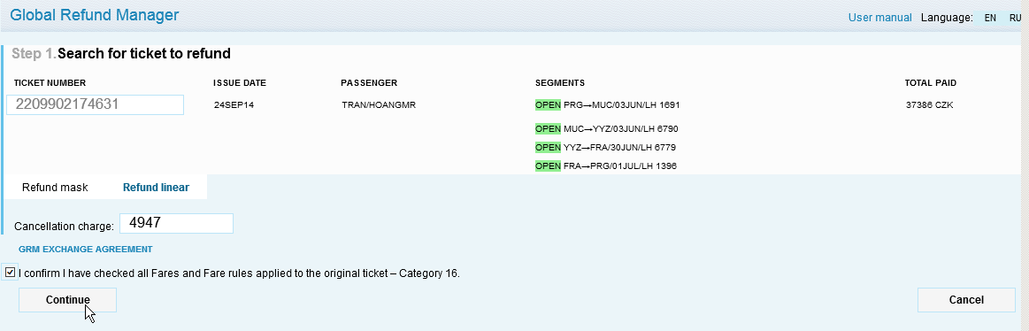

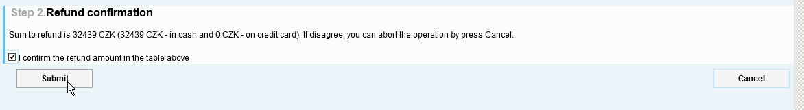

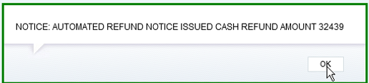

Full Refund including all taxes (XF and ZP) without cancel fee

TKT: 037 8953 327114 NAME: SRAMEK/PAVELMR
PH: 25 717 4277
ISSUED: 19FEB15 FOP:CASH
PSEUDO: 5C0L PLATING CARRIER: US ISO: CZ IATA: 15200054
USE CR FLT CLS DATE BRDOFF TIME ST F/B FARE CPN
OPEN US 2149 F 22APR DCABOS 1430 OK FA2AA 1
FARE USD 860.47 TAX 140AY TAX 1607US TAX 212XT
TOTAL CZK 23380
EQUIV CZK 21421
WAS US BOS 860.47 USD860.47END ZPDCA XT 100ZP112XF
DCA4.5
RLOC 1G N0XFRY US DMMCVJ

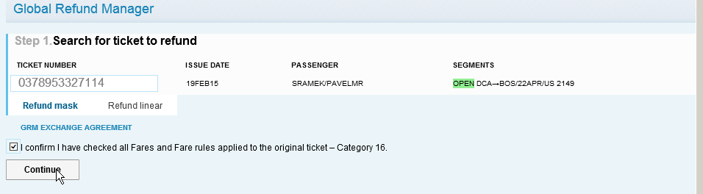

XT and ZP tax breakdown is entered automatically by GRM.

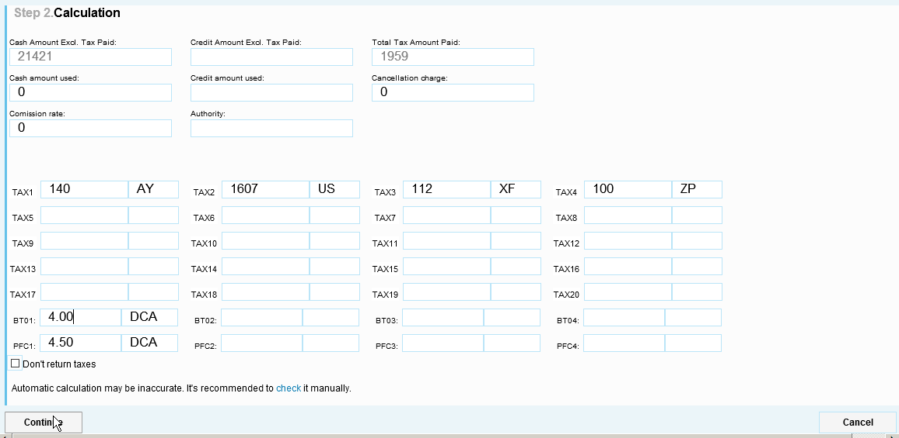

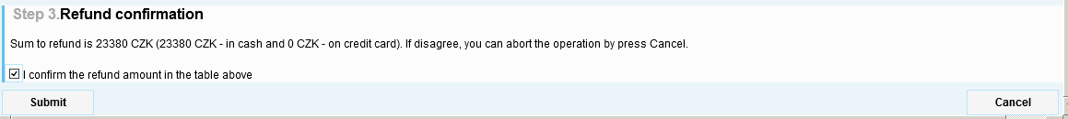

Refund of partly used ticket – involuntary refund due to LX1494 cancelled

TKT: 724 4869 704993 NAME: KREJCIK/JAKUBMR
ISSUED: 23JUL14 FOP:INVOICE
PSEUDO: 5C0L PLATING CARRIER: LX ISO: CZ IATA: 15200054
USE CR FLT CLS DATE BRDOFF TIME ST F/B FARE CPN
USED LX 1485 V 14AUG PRGZRH 1015 OK VNC2SCZ 1
NVB14AUG NVA14AUG
OPEN LX 1494 K 20JUN ZRHPRG 2130 OK KNN2SCZ 2
NVB20JUN NVA20JUN
FARE CZK 2601 TAX 583CZ TAX 839CH TAX 1400YQ
TOTAL CZK 5423
FARE RESTRICTIONS APPLY
PRG LX ZRH 111.39 LX PRG 17.41 NUC128.80END ROE20.1889
RLOC 1G NVT1VW LX F8F85F

As it is involuntary refund, the Fare used for return travel KNN2SCZ = NUC 17.41 can be fully refunded.

The amount in NUC must be converted to CZK (currency of commencement of transportation) using ROE valid at the time of ticketing.

>FZINUC17.41CZK.23JUL14
RATES LAST UPDATED 16JUL 00:30 AM
EQU CZK352 ROE 20.1889 NUC RATE MULTIPLIED BY ROE

Cash amount used: 2601 - 352 = 2249

In order to identify which taxes can be refunded, you have to calculate the journey already traveled (PRG ZRH) either using PNR if possible or using FQP function.

Calculation based on PNR: for OW calculation, YFFOWCZ fare will be used

>FQS1.Y.T23JUN14

Entry to display the Fare calculation:

>F*Q<

Q-1 M23JUN14 ADT
PRG LX ZRH 668.15YFFOWCZ NUC668.15END ROE19.8157
FARE CZK 13240 TAX CZ 583 TAX YQ 1204 TOT CZK 15027

Used taxes: CZ 583 and YQ 1204
Taxes to be refunded: CH 839 + YQ 196 (1400-1204) = 1035 CZK

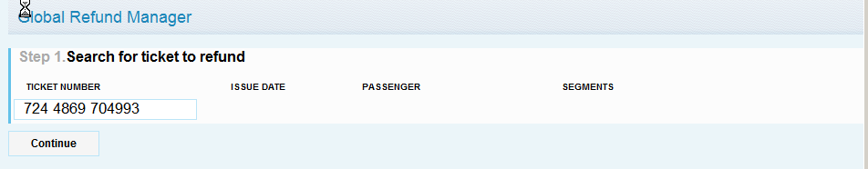

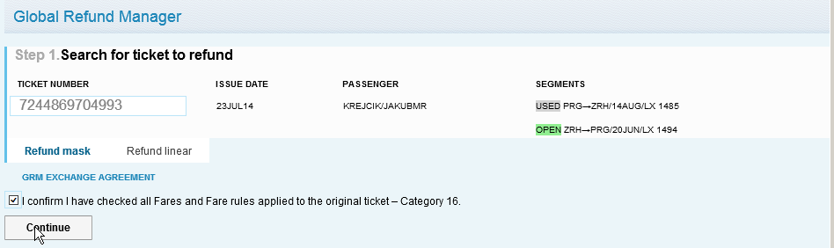

The Fare amount is not returned by the system and therefore is also missing in GRM Refund mask and must be added by the agent manually.

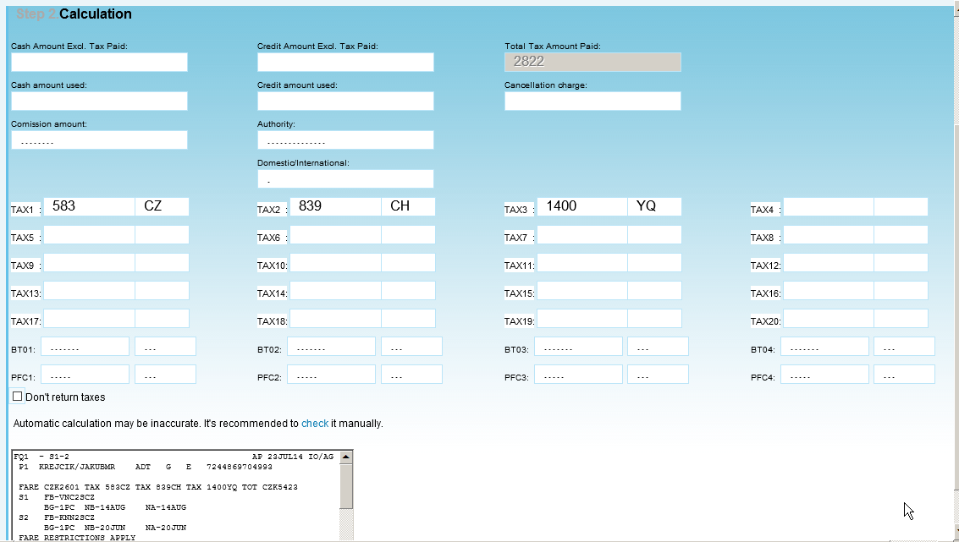

It is necessary to click on “TAX” field in front of CZ tax and it turns gray which means that this tax will not be refunded.
The amount for YQ tax must be changed manually by the agent to reflect the real refunded amount.

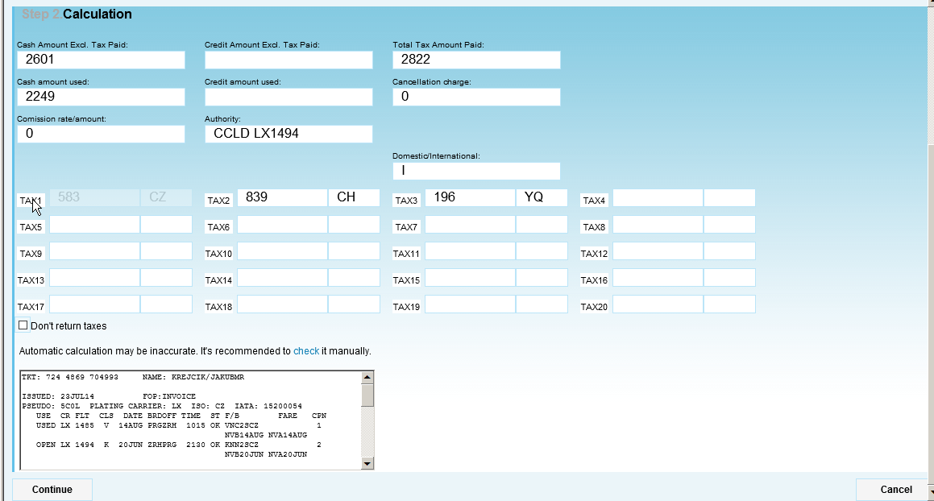
Waver code

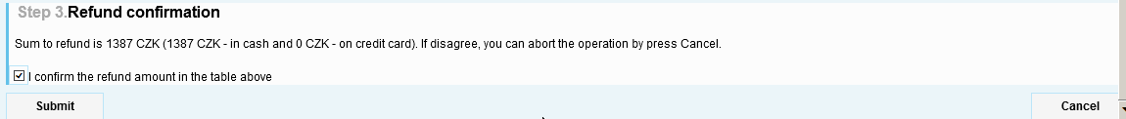

Refund of ticket partly paid by credit card and cash.

TKT: 555 9902 228103-104 NAME: KLEIN/TAMARAMRS
CC: AXXXXXXXXXXXX0000 PH: 42 077 797 6010
ISSUED: 27JAN15 FOP:AX-123456 T15210/CASH
PSEUDO: 79YE PLATING CARRIER: SU ISO: CZ IATA: 99999992
USE CR FLT CLS DATE BRDOFF TIME ST F/B FARE CPN
OPEN SU 2015 N 10AUG PRGSVO 1750 OK NHPX 1
NVB10AUG NVA10AUG
OPEN SU 0100 N 11AUG SVOJFK 0925 OK NHPX 2
NVB11AUG NVA11AUG
OPEN SU 4230 N 12AUG JFKTPA 1100 OK NHPX 3
NVB12AUG NVA12AUG
OPEN SU 4124 N 20AUG TPAJFK 0705 OK NHPX 4
NVB20AUG NVA20AUG
----104----
OPEN SU 0101 N 20AUG JFKSVO 1420 OK NHPX 1
NVB20AUG NVA20AUG
OPEN SU 2012 N 21AUG SVOPRG 1020 OK NHPX 2
NVB21AUG NVA21AUG
FARE CZK 14590 TAX 591CZ TAX 276AY TAX 9753XT
TOTAL CZK 25210
PRG SU X/MOW SU X/NYC SU TPA 325.88 SU X/NYC SU X/M
OW SU PRG 325.88 NUC651.76END ROE22.3844 XT 872US12
3XA173XY136YC7702YQ636YR111XF JFK4.5
RLOC 1G VHW73Y SU VKQOOC

The amount paid by CC = CZK 15210, which is 14590 for Fare and 620 for taxes.
The amount paid cash = CZK 10000

Category 16 of the appropriate Fare rule – Refund conditions:

>FN*1/16
001 PRGTPA 10AUG15 SU CZK 14590 NHPX STAY- V/165BK-N
16. PENALTIES
BETWEEN AREA 2 AND THE UNITED STATES
CANCELLATIONS
ANY TIME
TICKET IS NON-REFUNDABLE IN CASE OF CANCEL/NO-SHOW/
REFUND.
REFUND OF UNUSED FEES AND TAXES PERMITTED.

As the Fare is non-refundable, only CZK 620 will be refunded into the credit card.
Cash amount used for tax payment is fully refunded.

